### **Mayflower Thanksgiving Decoration**

Using the same body from my Columbus ship, I recreated a model of the Mayflower. The Mayflower is flying the St. George's Cross. St. George was the patron saint of England. I learned on our recent trip to England that the current English flag, the Union Jack is a mixture of the flags of England, Scotland and Ireland.

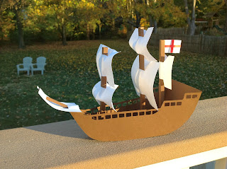

Please view my previous post as to how to put the ship together as the directions are the same except for the pole in the front of the ship which I glued directly to the front mast pole and the flag. I cut a vertical 1 inch slit in the mast pole starting at the top and glued the flag to the pole as shown in picture.  
  
My previous ship post:  
<http://papercraftetc.blogspot.com/2013/10/can-you-name-three-ships-that-sailed.html>